**Milestone 4 Marketing Analysis**

When presenting a new product to the public it is essential to know who to market your product to and have strategies that will attract attention to your product. In this section we will display our target market, profile of competitors, and our competitive advantage over competitors.

Target Market:

Our product, Pantry Pros is attempting to ease the gap between affordable, convenient food and another trip to the grocery store. We will be providing a website that integrates the consumer’s purchased food in their pantry/ fridge to relatable, easy-to-follow recipes and cooking videos. Pantry Pros will be a simple design that is extremely user friendly targeting young adults from 18-25 or consumer’s simply on-the-move and aiming to maximize their time and diet on a budget with the products they already posses. The USA population in 2015 was about 300 million people and about 11% of the population was from 18-25 years of age. Many consumers in the age rage of 18-25 interact regularly with their mobile devices providing us an easy channel to integrate into. The problem we are attempting to solve is budget consumption and lack of knowledge of cooking present in young adults.

Customers that would benefit from our product include intermediate to beginner level cooks that can quickly and easily gain knowledge about preparing a well balanced meal. Customers that maintain a low budget diet would benefit utilizing the food in their pantry already to cut back on time traveling to the store or eating out. Once we successfully attracted our original target market we plan to next target people from 30-50 years old. We will reach these people the same way via social media and word of mouth from our young target market. We envision our young target market to be excited about product and show it to their friends and family. If this occurs we our target will expand from 18-25 year olds to 18-50 year olds in just a few months increasing our target market from 11% to 43%. The rate this market grows and shrinks is about 士5% in the last 15 years. The demographics of both target markets are planned to be generic. Our product will provide recipes for athletes to couch potatoes, poor college kids to successful parents, and food from all cultures. Broadening our product will allow us to maximize our target market. A link provided below is displayed to validate our target market statistics.

<https://www.census.gov/popclock/>

Profile of Competitors:

Unfortunately our product is not the only one on the market; upon further research we have found at least two competitors. The first competitor, MyFridgeFood, is a website that gives users recipes after entering the food they have. A disadvantage that MyFridgeFood has is the ability to save the food a user has in their pantry. Once the food is entered a list of recipes will be displayed, but if you leave the webpage a user will have to re-enter the food they have in order to find their recipes again. A picture of our competitors website can be seen below.

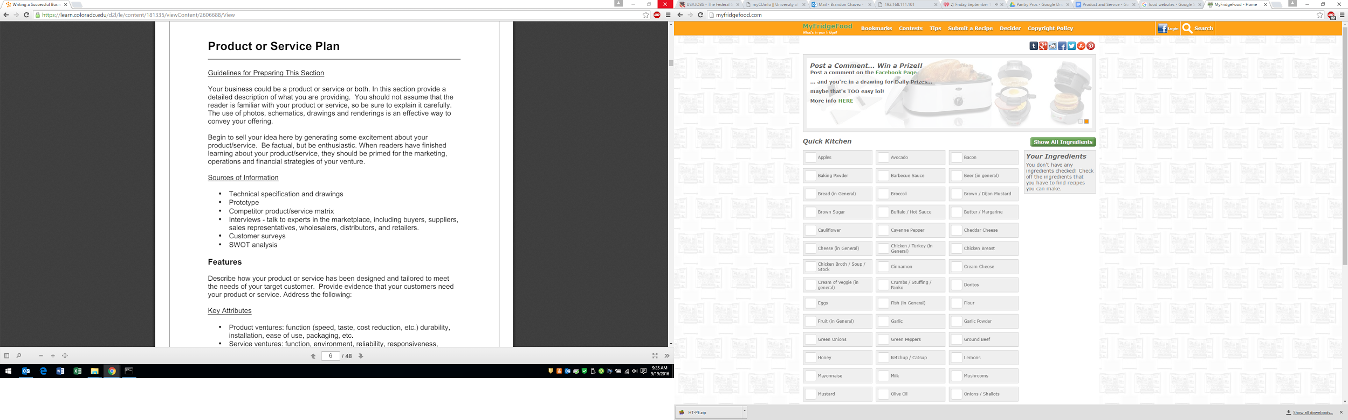

Another competitor we have is Carrot, a mobile application that displays recipes from the food a user enters into the application. Carrot has an advantage over MyFridgeFood because it gives the user the ability to save the food in their pantry and not have to re-enter it every time they use the application. Carrot also has moving icons in the recipe list giving the user a visual representation of how to prepare the meal. Below are a few screenshots of the Carrot applications.

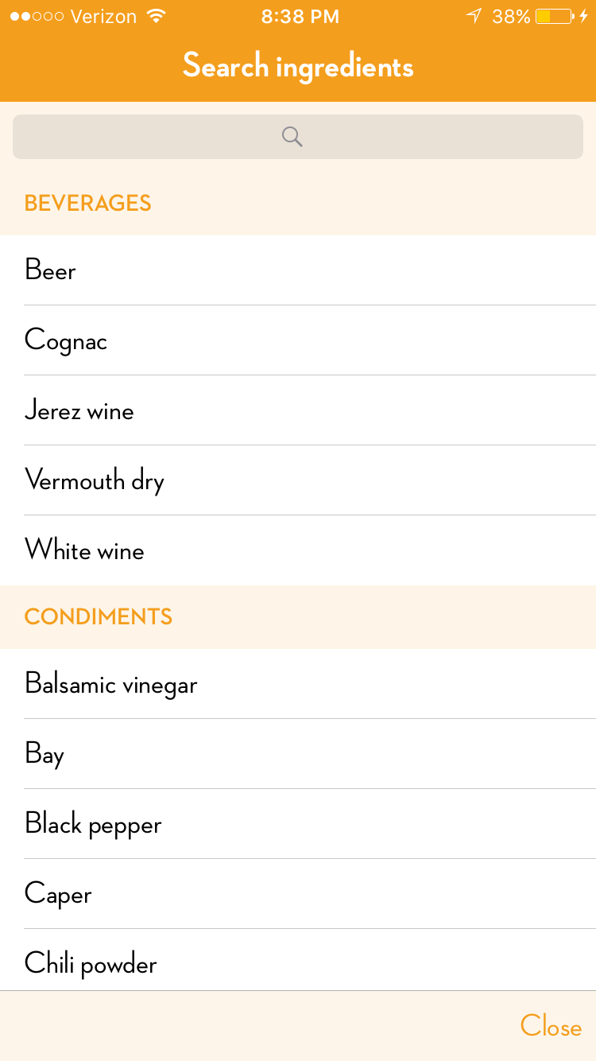

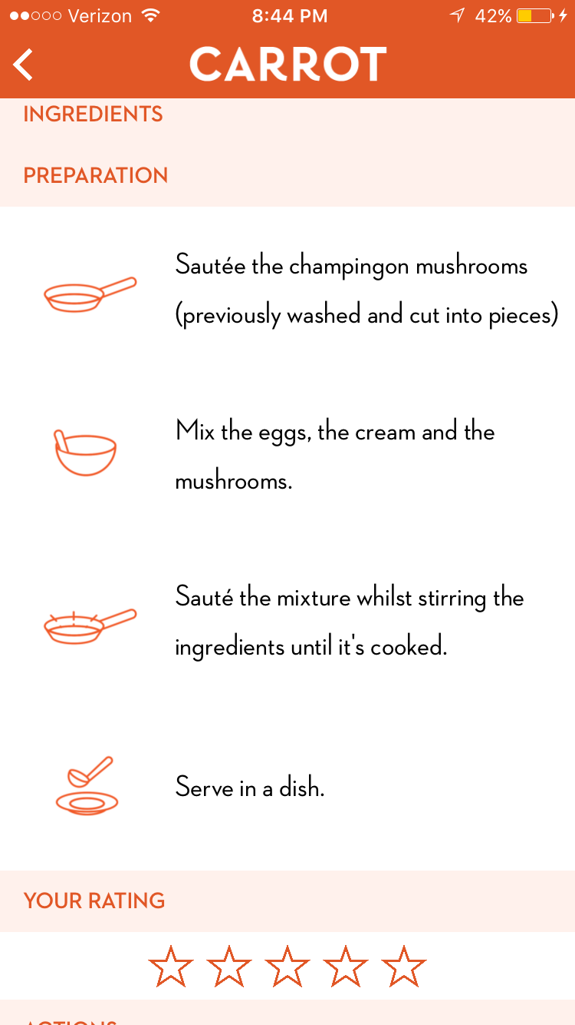

Competitive Advantage:

Understanding who are competitors are it is important to know where our product stands in comparison and what features we can offer to gain a competitive advantage. At the very least we plan to offer the same features our main competitor does. For example Carrot gives the user the ability to save the items in the their pantry. To gain a competitive advantage we plan on having videos that demonstrate how to prepare the meal in addition to the recipes. We also will have a competitive advantage by giving users ‘points’ every time they share our product on social media. Once a specific number of points are achieved the user will have access to a ‘secret recipe’ that only our product offers. This is similar to ‘Netflix originals’ that are only offered to netflix subscribers. This will keep our users from using our competitor's platforms. During development of our product we plan to give contracts to companies that offer some of our features such as the videos. These contracts will restrict the companies to work with our competitors ensuring our product is unique. Ensuring our target market thinks positively of our brand we will trademark our company name and copyright or logo and website layout if it is unique enough. Doing so will protect our brand and image creating customer loyalty since our product and our competitors offer a similar service.

Infographic

Displayed below is an image of our website. We have created our website homepage to quickly and clearly present our product’s service. While developing the homepage we purposely enhanced capabilities of the human visual system by providing patterns and trends.

Results of the retrospective on first iteration:

Since our first iteration we have been both successful and unsuccessful. Luckily the management tools and code repository that we chose have worked and been successful. While creating the website we were unsuccessful using the first website platform [www.wordpress.com](http://www.wordpress.com). Using this website allowed us to easily layout and build a website however, we did not have the ability to take record data that was entered by a user. It is important for us to record the data a user enters because this is how we will know what recipes to display to the user based on the food they have. Since then we have started to work with [www.wordpress.org](http://www.wordpress.org) which allows us to maniuplate our website and gives us the freedom we need. We also are using DigiatlOcean as a host provider which so far has been successful .

The new iteration of the product will be a working website that stores a user’s data in our MYSQL database. We also plan on on inputting a few videos in addition to the recipes that are displayed. In future iterations we plan to allow users to like videos seen on social media platforms and have the ingredients that are needed imported into the ‘grocery list’ on our website.